
FURTHER EDUCATION AND TRAINING CERTIFICATE: INFORMATION TECHNOLOGY: SYSTEMS DEVELOPMENT
ID 78965 LEVEL 4 – CREDITS 165
LEARNER GUIDE
SAQA: 14944
EXPLAIN HOW DATA IS STORED ON COMPUTERS

Learner Information:
Details | Please Complete this Section
Name & Surname:
Organisation:
Unit/Dept:
Facilitator Name:
Date Started:
Date of Completion:

Copyright
All rights reserved. The copyright of this document, its previous editions and any annexures thereto, is protected and expressly reserved. No part of this document may be reproduced, stored in a retrievable system, or transmitted, in any form or by any means, electronic, mechanical, photocopying, recording or otherwise without the prior permission.

Key to Icons
The following icons may be used in this Learner Guide to indicate specific functions:
  Books | This icon means that other books are available for further information on a particular topic/subject.
  References | This icon refers to any examples, handouts, checklists, etc…
  Important | This icon represents important information related to a specific topic or section of the guide.
  Activities | This icon helps you to be prepared for the learning to follow or assist you to demonstrate understanding of module content. Shows transference of knowledge and skill.
  Exercises | This icon represents any exercise to be completed on a specific topic at home by you or in a group.
  Tasks/Projects | An important aspect of the assessment process is proof of competence. This can be achieved by observation or a portfolio of evidence should be submitted in this regard.
  Workplace Activities | An important aspect of learning is through workplace experience. Activities with this icon can only be completed once a learner is in the workplace
  Tips | This icon indicates practical tips you can adopt in the future.
  Notes | This icon represents important notes you must remember as part of the learning process.

Learner Guide Introduction

About the Learner Guide… | This Learner Guide provides a comprehensive overview of the EXPLAIN HOW DATA IS STORED ON COMPUTERS,and forms part of a series of Learner Guides that have been developed for The series of Learner Guides are conceptualized in modular’s format and developed They are designed to improve the skills and knowledge of learners, and thus enabling them to effectively and efficiently complete specific tasks. Learners are required to attend training workshops as a group or as specified by their organization. These workshops are presented in modules, and conducted by a qualified facilitator.
Purpose | The purpose of this Unit Standard is to Explain how data is stored on computers
Outcomes | Explain how data is stored on computers
Assessment Criteria | The only way to establish whether a learner is competent and has accomplished the specific outcomes is through an assessment process. Assessment involves collecting and interpreting evidence about the learner’s ability to perform a task.This guide may include assessments in the form of activities, assignments, tasks or projects, as well as workplace practical tasks. Learners are required to perform tasks on the job to collect enough and appropriate evidence for their portfolio of evidence, proof signed by their supervisor that the tasks were performed successfully.
To qualify | To qualify and receive credits towards the learning programme, a registered assessor will conduct an evaluation and assessment of the learner’s portfolio of evidence and competency
Range of Learning | This describes the situation and circumstance in which competence must be demonstrated and the parameters in which learners operate
Responsibility | The responsibility of learning rest with the learner, so:  - Be proactive and ask questions,  - Seek assistance and help from your facilitators, if required.

Learning Unit1
UNIT STANDARD NUMBER : 14944
Explain how data is stored on computers
LEVEL ON THE NQF : 4
CREDITS : 7
FIELD : Physical, Mathematical, Computer and Life Sciences
SUB FIELD : Construction Information Technology and Computer Sciences

PURPOSE: | This unit standard is intended:  to provide conceptual knowledge of the areas covered  for those working in, or entering the workplace in the area of Information Systems and Technology Management  as additional knowledge for those wanting to understand the areas covered  People credited with this unit standard are able to:  Describe the roles of IS departments in organisations  Describe the structures of IS departments in organisations  The performance of all elements is to a standard that allows for further learning in this area.
LEARNING ASSUMED TO BE IN PLACE:
The credit value of this unit is based on a person having prior knowledge and skills to:
Demonstrate an understanding of fundamental mathematics (at least NQF level 3).
Demonstrate PC competency skills (End-User Computing unit Standards, at least up to NQF level 3).

SESSION 1.
Demonstrate an understanding of computer data types.
Learning Outcomes
- 1. The demonstration distinguishes between data types and includes examples.
- 2. The description of the use of coding systems in a business environment distinguishes categories of coding systems and includes examples.
- 3. The demonstration illustrates how data manipulation operations are performed on data types.

The demonstration distinguishes between data types and includes examples.
A data type is a classification of the type of data that a variable or object can hold in computer programming. Data type is an important factor in virtually all computer programming languages, including visual basic, C#, C++ and JavaScript. When programmers create computer applications, both desktop and web-based, data types must be referenced and used correctly, to ensure the result of the application's functions is correct and error-free.
PRIMITIVE DATA TYPE
- Boolean type
Boolean data type refers to those types of computer data which represent the values in two forms i.e. true and false. All the values are represented as true and false or yes and no. these are also known as logical data. In some software, it has been interpreted in the form of numbers which indicates either its true or false, 0 is considered as false while other digit is referred as true.
- Numeric type
Numeric data is one of the very common types of computer data which simply means numbers. Numbers can be many forms including, integers, real numbers, currency calculation, percentage, binary numbers etc. some software use different language for such numeric type of data which includes, single, double or float.
1. Integers: It is consisting of whole numbers and can be represented in negative as well as positive. It doesn’t have any decimal values.
2. Real numbers: It contains decimal and fractional values as well and can be represented in negative and positive.
3. Currency: It contains a specific symbol which refers to a particular country. This type of numeric value is recorded till two decimal digits.
4. Percentage: Percentage values are recorded in a way that it is calculated out of 100 and can be denoted in a whole number as well as in decimal values. It has a specific percentage symbol (%) which is used to indicate percentage value.
COMPOSITE DATA TYPE
Composite data type is a combination of primitive data type; they combine to form composite data type which is also known as data structure. There are different types of composite data, which serves different purposes like, array, union, record, sets, objects and tagged union.
ALPHANUMERIC DATA TYPE:
Alphanumeric data simply means one of the types of computer data that contains alphabets as well as numbers. It is very common type of data storage system, which allows different type of computer data to store in one place. It contains alphabets, numbers, symbols, space and punctuation marks. It records every bit of details you want to store in your computer. It is also referred as text data.
ABSTRACT DATA TYPE:
Abstract data type is one of the rare types of computer data; it doesn’t have any representation and implementation. It is just a vague term or language used which don’t have any purpose. Array and records contain such types of computer data, they are considered as concrete as they specify the elements present it a memory.
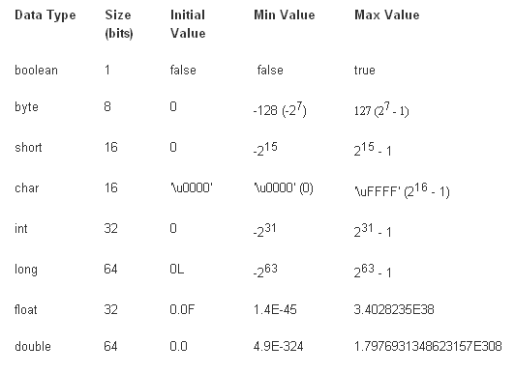
The description of the use of coding systems in a business environment distinguishes categories of coding systems and includes examples.
COMPUTER CODING SYSTEMS
To represent numeric, alphabetic, and special characters in a computer's internal storage and on magnetic media, we must use some sort of coding system. In computers, the code is made up of fixed size groups of binary positions. Each binary position in a group is assigned a specific value; for example 8, 4, 2, or 1. In this way, every character can be represented by a combination of bits that is different from any other combination.In this section you will learn how the selected coding systems are used to represent data. The coding systems included are Extended Binary Coded Decimal Interchange Code (EBCDIC), and American Standard Code for Information Interchange (ASCII).

EXTENDED BINARY CODED DECIMAL INTERCHANGE CODE (EBCDIC)
Using an 8-bit code, it is possible to represent 256 different characters or bit combinations. This provides a unique code for each decimal value 0 through 9 (for a total of 10), each uppercase and lowercase letter (for a total of 52), and for a variety of special characters. In addition to four numeric bits, four zone bit positions are used in 8-bit code as illustrated. Each group of the eight bits makes up one alphabetic, numeric, or special character and is called a byte.
Figure 1. - Format for EBCDIC and ASCII codes.
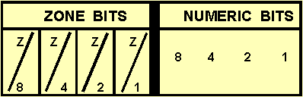
When you look at figure 1, you will notice that the four rightmost bits in EBCDIC are assigned values of 8, 4, 2, and 1. The next four bits to the left are called the zone bits. The EBCDIC coding chart for uppercase and lowercase alphabetic characters and for the numeric digits 0 through 9 is shown in figure 2, with their hexadecimal equivalents. Hexadecimal is a number system used with some computer systems. It has a base of 16 (0-9 and A-F). A represents 10; B represents 11; C represents 12; D represents 13; E represents 14; and F represents 15. In EBCDIC, the bit pattern 1100 is the zone combination used for the alphabetic characters A through I, 1101 is used for the characters J through R, and 1110 is the zone combination used for characters S through Z. The bit pattern 1111 is the zone combination used when representing decimal digits. For example, the code 11000001 is equivalent to the letter A; the code 11110001 is equivalent to the decimal digit 1. Other zone combinations are used when forming special characters. Not all of the 256 combinations of 8-bit code have been assigned characters. characters DP-3 are represented using EBCDIC.
Figure 2.- Eight-bit EBCDIC coding chart (including exadecimal equivalents).
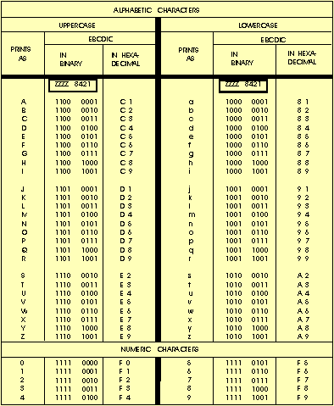
. - DP-3 represented using 8-bit EBCDIC code.
DP - 31100 01001101 01110110 00001111 0011
Since one numeric character can be represented and stored using only four bits (8-4-2-1), using an 8-bit code allows the representation of two numeric characters (decimal digits) as illustrated. Representing two numeric characters in one byte (eight bits) is referred to as packing or packed data. By packing data (numeric characters only) in this way, it allows us to conserve the amount of storage space required, and at the same time, increases processing speed.
Figure 4. - Packed data.
DECIMAL VALUE | 92 | 73
EBCDIC | 10010010 | 01110011
BIT PLACE VALUES | 84218421 | 8421
8421 | B Y T E 1 | B Y T E 2

AMERICAN STANDARD CODE FOR INFORMATION INTERCHANGE (ASCII)
Another 8-bit code, known as the American Standard Code for Information Interchange (ASCII) (pronounced ASS-KEY), was originally designed as a 7-bit code. Several computer manufacturers cooperated to develop this code for transmitting and processing data. The purpose was to standardize a binary code to give the computer user the capability of using several machines to process data regardless of the manufacturer: IBM, HONEYWELL, UNIVAC, BURROUGHS, and so on. However, since most computers are designed to handle (store and manipulate) 8-bit code, an 8-bit version of ASCII was developed. ASCII is commonly used in the transmission of data through data communications and is used almost exclusively to represent data internally in microcomputers. The concepts and advantages of ASCII are identical to those of EBCDIC. The important difference between the two coding systems lies in the 8-bit combinations assigned to represent the various alphabetic, numeric, and special characters. When using ASCII 8-bit code, you will notice the selection of bit patterns used in the positions differs from those used in EBCDIC. For example, let's look at the characters DP3 in both EBCDIC and ASCII to see how they compare.
Character | D | P | 3
EBCDIC | 1100 0100 | 1101 0111 | 1111 0011
ASCII | 0100 0100 | 0101 0000 | 0011 0011
In ASCII, rather than breaking letters into three groups, uppercase letters are assigned codes beginning with hexadecimal value 41 and continuing sequentially through hexadecimal value 5A. Similarly, lowercase letters are assigned hexadecimal values of 61 through 7A.The decimal values 1 through 9 are assigned the zone code 0011 in ASCII rather that 1111 as in EBCDIC. Figure 4-7 is the ASCII coding chart showing uppercase and lowercase alphabetic characters and numeric digits 0 through 9.
Eight-bit ASCII coding chart (including hexadecimal equivalents).
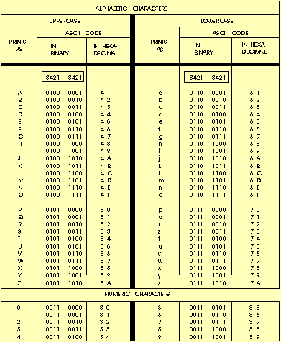
At this point you should understand how coding systems are used to represent data in both EBCDIC and ASCII. Regardless of what coding system is used, each character will have an additional bit called a check bit or parity bit.
PARITY BIT
This additional check or parity bit in each storage location is used to detect errors in the circuitry. Therefore, a computer that uses an 8-bit code, such as EBCDIC or ASCII, will have a ninth bit for parity checking. The parity bit (also called a check bit, the C position in a code) provides an internal means for checking the validity, the correctness, of code construction. That is, the total number of bits in a character, including the parity bit, must always be odd or always be even, depending upon whether the particular computer system or device you are using is odd or even parity. Therefore, the coding is said to be in either odd or even parity code, and the test for bit count is called a parity check.
Now, let's talk about bits and bytes, primary storage, and storage capacities; or, to put it another way, the capacity of a storage location. Sit back, keeps your memory cycling, and we will explain the ways data may be stored and retrieved inside the computer.
Q.6 what does the acronym EBCDIC stand for?
Q.7 by using an 8-bit code, how many characters or bit combinations can be represented?
Q.8 what is the base of a hexadecimal number system?
Q.9 what term is used for the representation of two numeric characters stored in eight bits?
Q.10 what does the acronym ASCII mean?
Q.11 what was the purpose of several computer manufacturers cooperating to develop ASCIIcode for processing and transmitting data?
Q.12 Are there any differences in the concepts and advantages of ASCII and EBCDIC?
Q.13 how is the parity bit in each storage location used?
Q.14 A computer or device that uses 8-bit ASCII or EBCDIC will use how many bits to store each character?

A6. Extended Binary Coded Decimal Interchange Code.
A7. 256.
A8. 16.
A9. Packing or packed data.
A10. American Standard Code for Information Interchange.
A11. To standardize a binary code to give the computer user the capability of using several machines to process data regardless of the manufacturer.
A12. No, they are identical.
A13. To detect errors in the circuitry.
A14. Nine.

Data manipulation involves performing calculations on numbers and manipulating strings. Programs manipulate and use variables in many ways, often depending on the type of the data. Each data type has a number of operations - things that you can do to it. There are 3 major set of operators in most programming languages - Numeric or Arithmetic operators, Comparison operators and Logical operators. Let's know each set in detail.
Numeric or Arithmetic Operators
+ Addition
- Subtraction
* Multiplication
/ Division
\ Integer division
Mod Modulus arithmetic
& String concatenation
Arithmetic operators for manipulating data include the familiar addition, subtraction, multiplication and division operators. There are some interesting variations such as the modulus (Mod) and integer division (\) available in visual basic.

Fortran data types
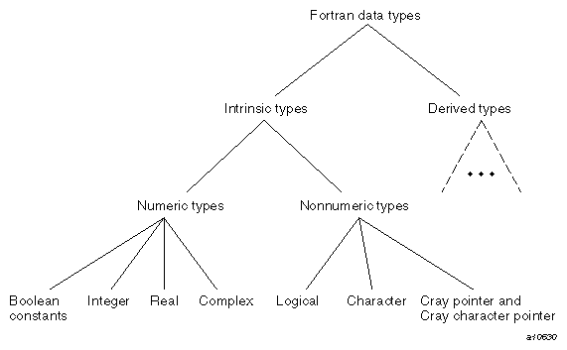
As the following list shows, the type of the data determines the operations that can be performed on it:
Data Type | Operations
Real, complex, integer, Boolean | Addition, subtraction, multiplication, division, exponentiation, negation, comparison, masking expressions
Logical | Negation, conjunction, disjunction, and equivalence
Character | Concatenation, comparison
User defined | User defined
Cray pointer, Cray character pointer | Addition, subtraction, and LOC( ) function
The intrinsic types have the appropriate built-in (intrinsic) operations. You must define the operations performed on user-defined data types.

Bit manipulation in the C programming language
C has direct support for bitwise operations that can be used for bit manipulation. In the following examples, n is the index of the bit to be manipulated within the variable bit_fld, which is anunsigned char being used as a bit field. Bit indexing begins at 0, not 1. Bit 0 is the least significant bit.
Set a bit
bit_fld |= (1 << n)
Clear a bit
bit_fld &= ~(1 << n)
Toggle a bit
bit_fld ^= (1 << n)
Test a bit
bit_fld & (1 << n)
When using an array of bytes to represent set of bits, i.e., a bit array or bitset, the index of the byte in the array associated with a bit n can be calculated using division:

SESSION 2.
Describe computer data structures.
Learning Outcomes
- 1. The description distinguishes types of computer data structures and identifies examples.
- 2. The description distinguishes types of computer files and identifies examples.
- 3. The description distinguishes types of computer databases and identifies examples.

The description distinguishes types of computer data structures and identifies examples.
In computer science, a data structure is a particular way of storing and organizing data in a computer so that it can be used efficiently. Different kinds of data structures are suited to different kinds of applications, and some are highly specialized to specific tasks. For example, B-trees are particularly well-suited for implementation of databases, while compiler implementations usually use hash tables to look up identifiers.

Data structures
Whereas control structures organize algorithms, data structures organize information. In particular, data structures specify types of data, and thus which operations can be performed on them, while eliminating the need for a programmer to keep track of memory addresses. Simple data structures include integers, real numbers, Booleans (true/false), and characters or character strings. Compound data structures are formed by combining one or more data types.The most important compound data structures are the array, a homogeneous collection of data, and the record, a heterogeneous collection. An array may represent a vector of numbers, a list of strings, or
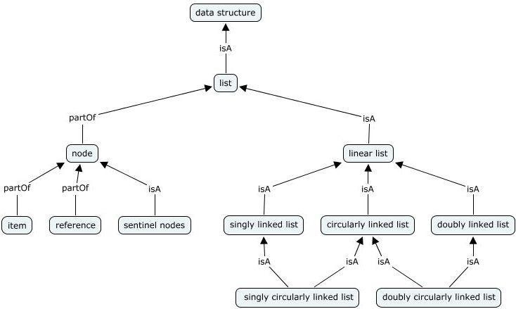
Data structure, Way in which data are stored for efficient search and retrieval. The simplest data structure is the one-dimensional (linear) array, in which stored elements are numbered with consecutive integers and contents are accessed by these numbers. Data items stored no consecutively in memory may be linked by pointers (memory addresses stored with items to indicate where the “next” item or items in the structure are located). Many algorithms have been developed for sorting data efficiently; these apply to structures residing in main memory and also to structures that constitute information systems and databases. Bits, Bytes, Characters, Fields, Records, Files, and Databases are examples

The description distinguishes types of computer files and identifies examples.
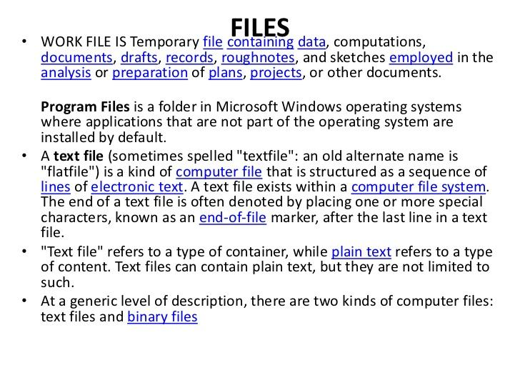

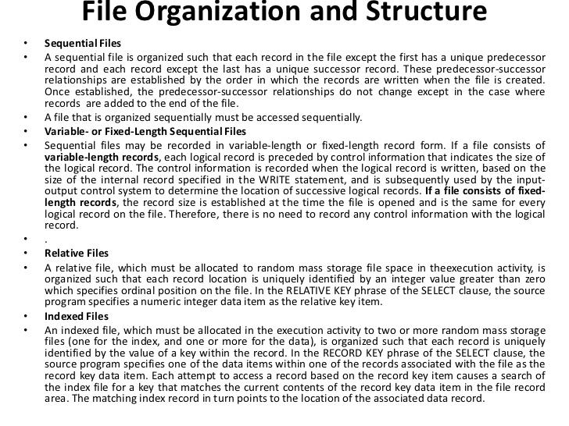

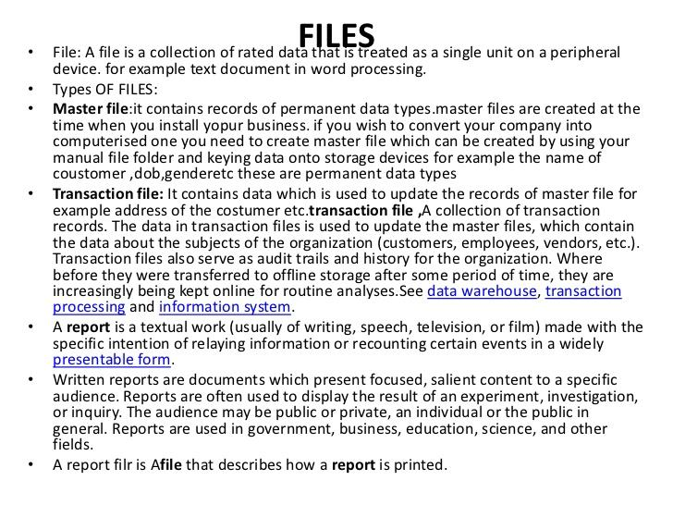
The description distinguishes types of computer databases and identifies examples.
Types of Database Management Systems
DBMSs come in many shapes and sizes. For a few hundred dollars, you can purchase a DBMS for your desktop computer. For larger computer systems, much more expensive DBMSs are required. Many mainframe-based DBMSs are leased by organizations. DBMSs of this scale are highly sophisticated and would be extremely expensive to develop from scratch. Therefore, it is cheaper for an organization to lease such a DBMS program than to develop it. Since there are a variety of DBMSs available, you should know some of the basic features, as well as strengths and weaknesses, of the major types.
After reading this lesson, you should be able to:
- Compare and contrast the structure of different database management systems.
- Define hierarchical databases.
- Define network databases.
- Define relational databases.
- Define object-oriented databases.
Types of DBMS: Hierarchical Databases
There are four structural types of database management systems: hierarchical, network, relational, and object-oriented.
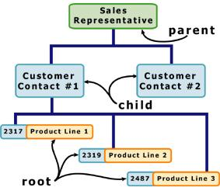
Hierarchical Databases (DBMS), commonly used on mainframe computers, have been around for a long time. It is one of the oldest methods of organizing and storing data, and it is still used by some organizations for making travel reservations. A hierarchical database is organized in pyramid fashion, like the branches of a tree extending downwards. Related fields or records are grouped together so that there are higher-level records and lower-level records, just like the parents in a family tree sit above the subordinated children. Based on this analogy, the parent record at the top of the pyramid is called the root record. A child record always has only one parent record to which it is linked, just like in a normal family tree. In contrast, a parent record may have more than one child record linked to it. Hierarchical databases work by moving from the top down. A record search is conducted by starting at the top of the pyramid and working down through the tree from parent to child until the appropriate child record is found. Furthermore, each child can also be a parent with children underneath it.
The advantage of hierarchical databases is that they can be accessed and updated rapidly because the tree-like structure and the relationships between records are defined in advance. However, this feature is a two-edged sword. The disadvantage of this type of database structure is that each child in the tree may have only one parent, and relationships or linkages between children are not permitted, even if they make sense from a logical standpoint. Hierarchical databases are so rigid in their design that adding a new field or record requires that the entire database be redefined.
Types of DBMS: Network Databases
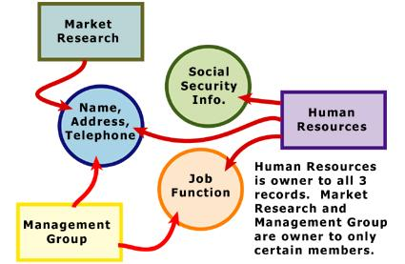
Network databases are similar to hierarchical databases by also having a hierarchical structure. There are a few key differences, however. Instead of looking like an upside-down tree, a network database looks more like a cobweb or interconnected network of records. In network databases, children are called members and parents are called owners. The most important difference is that each child or member can have more than one parent (or owner).Like hierarchical databases, network databases are principally used on mainframe computers. Since more connections can be made between different types of data, network databases are considered more flexible. However, two limitations must be considered when using this kind of database. Similar to hierarchical databases, network databases must be defined in advance. There is also a limit to the number of connections that can be made between records.
Types of DBMS: Relational Databases
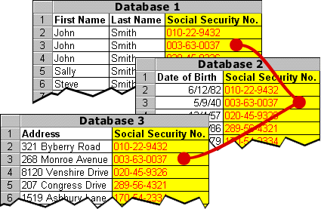
In relational databases, the relationship between data files is relational, not hierarchical. Hierarchical and network databases require the user to pass down through a hierarchy in order to access needed data. Relational databases connect data in different files by using common data elements or a key field. Data in relational databases is stored in different tables, each having a key field that uniquely identifies each row. Relational databases are more flexible than either the hierarchical or network database structures. In relational databases, tables or files filled with data are called relations, tuples designates a row or record, and columns are referred to as attributes or fields. Relational databases work on the principle that each table has a key field that uniquely identifies each row, and that these key fields can be used to connect one table of data to another. Thus, one table might have a row consisting of a customer account number as the key field along with address and telephone number. The customer account number in this table could be linked to another table of data that also includes customer account number (a key field), but in this case, contains information about product returns, including an item number (another key field). This key field can be linked to another table that contains item numbers and other product information such as production location, color, quality control person, and other data. Therefore, using this database, customer information can be linked to specific product information.
The relational database has become quite popular for two major reasons. First, relational databases can be used with little or no training. Second, database entries can be modified without redefining the entire structure. The downside of using a relational database is that searching for data can take more time than if other methods are used.
Types of DBMS: Object-oriented Databases (OODBMS)
Able to handle many new data types, including graphics, photographs, audio, and video, object-oriented databases represent a significant advance over their other database cousins. Hierarchical and network databases are all designed to handle structured data; that is, data that fits nicely into fields, rows, and columns. They are useful for handling small snippets of information such as names, addresses, zip codes, product numbers, and any kind of statistic or number you can think of. On the other hand, an object-oriented database can be used to store data from a variety of media sources, such as photographs and text, and produce work, as output, in a multimedia format. Object-oriented databases use small, reusable chunks of software called objects. The objects themselves are stored in the object-oriented database. Each object consists of two elements: 1) a piece of data (e.g., sound, video, text, or graphics), and 2) the instructions, or software programs called methods, for what to do with the data. Part two of this definition requires a little more explanation. The instructions contained within the object are used to do something with the data in the object. For example, test scores would be within the object as would the instructions for calculating average test score. Object-oriented databases have two disadvantages. First, they are more costly to develop. Second, most organizations are reluctant to abandon or convert from those databases that they have already invested money in developing and implementing. However, the benefits to object-oriented databases are compelling. The ability to mix and match reusable objects provides incredible multimedia capability. Healthcare organizations, for example, can store, track, and recall CAT scans, X-rays, electrocardiograms and many other forms of crucial data.

Now that you have completed this lesson, you should be able to:
- Compare and contrast the structure of different database management systems.
- Define hierarchical databases.
- Define network databases.
- Define relational databases.
- Define object-oriented databases.

